TO: CIO  
FROM: Team 5  
SUBJECT: RE: Edge Router ACLs

The edge router now has ACLs setup.

Palo Alto has Zone Protection Profiles to drop improper packets.

Under Network and Network Profiles, Zone Protection Profile Objects can be setup (Figure 1).

After setting up the object, the object profile needs to be applied to a specific external zone (Figure 2).

Commit changes on Palo Alto to apply settings.

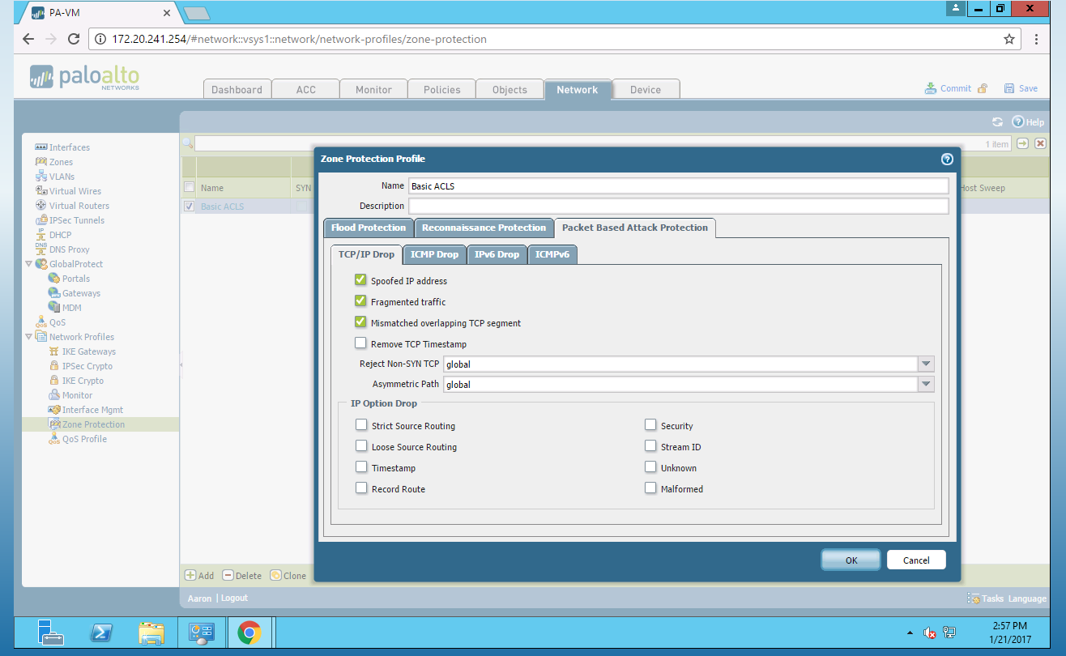

Figure

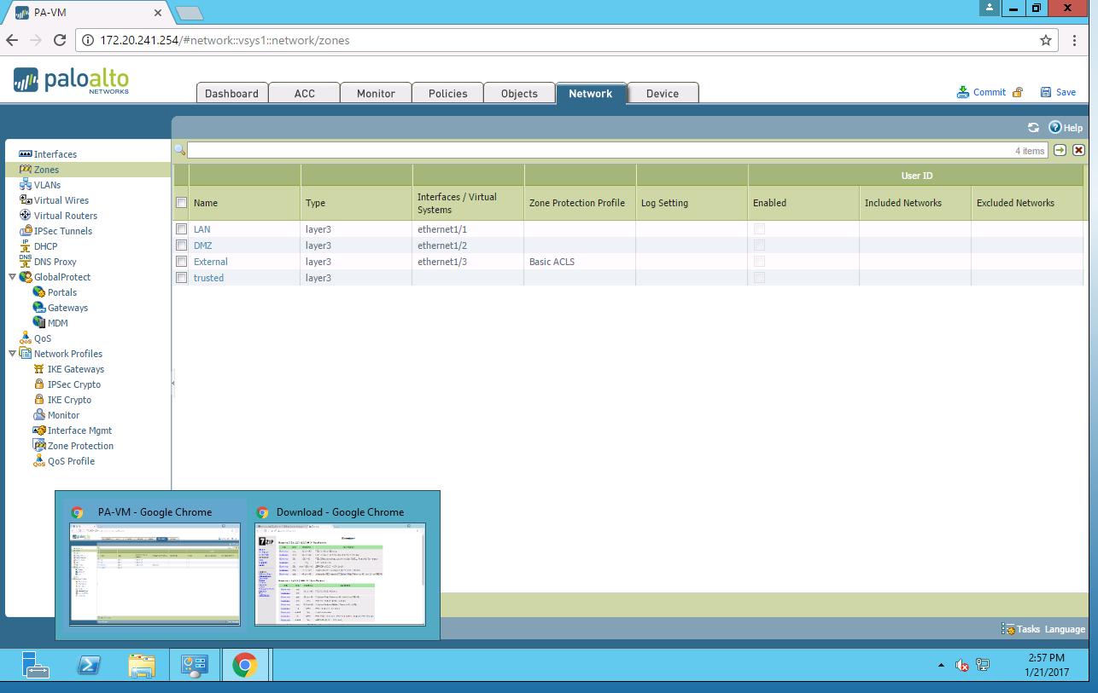

Figure